Ancient Civilisations
The Mediterranean World

The Task:
Choose one of the following Mediterranean Civilisations to research.
- Ancient Rome
- Ancient Greece
- Ancient Egypt
Once you have chosen your civilisation, you must research the following aspects of that society: The geographic features of the land; the social structure; the government and laws; the religious practices; and the contact and conflict with other societies.

Your research may be presented in one of the following modes: a report with headings, a PowerPoint presentation, a poster, or an oral (presented in person or filmed/edited). You must include visual aids such as images and maps to support your presentation.

A bibliography must also be included in your report. You must use the bibliography scaffold provided.

Research checklist:
- The Geographic Features of the land
- What was the landscape like and how did it benefit the people that lived there?
- Information about rivers, mountains, oceans, food and water sources etc.
- Include a map showing these features.
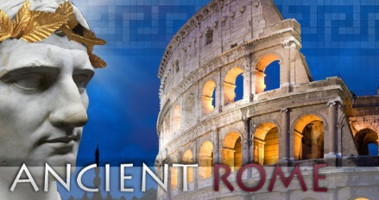
- Social Structure
- What were the roles of key groups in society?
- Include a diagram/pyramid of the social structure.

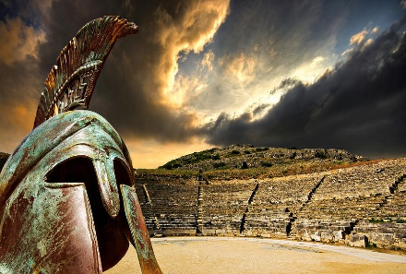
- Government and Laws
- What type of government did they have?
- How was the government chosen?
- How were laws made?
ANCIENT GREECE

- Religious practices
- What gods did they believe in?
- Were temples and priests used?
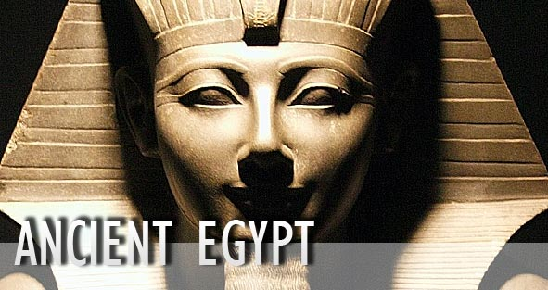
- What types of rituals or ceremonies were performed?

- Contact & Conflict with other societies
- ROME vs. Carthage - the Punic Wars
- GREECE vs. The Persian Empire - the Persian Wars
- EGYPT vs. The Hittite Empire - wars and peace treaty

DUE DATE – Friday, Week 8, Term 2.
The Mediterranean World Project
Criteria | A (5) Extensive | B (4) Thorough | C (3)  Sound | D (2)  Basic | E (1)  Elementary
Research Skills | Evidence of extensive research. Student has found additional information other than what is listed. All research is dot pointed in clear notes in their own words. | Evidence of thorough research. Student has found information on all areas listed. All research is dot pointed in clear notes. | Evidence of sound research. Sufficient research in most areas listed. All research is dot pointed. | Evidence of basic research. Student has attempted to research most areas listed. | Evidence of elementary research. Student has attempted to research few areas listed.
Report information | Text is supported with extensive historical evidence and examples. Info has a clear structure and is written in paragraphs with headings and sub-headings. | Text is supported with thorough historical evidence and examples. Info has a good structure and is written in paragraphs with headings. | Text is supported with sound historical evidence. Info has a structure and is written in paragraphs with headings. | Text is supported with basic historical evidence. Info has a very basic structure and is written in dot points. | Text is brief and not supported with historical evidence. Info has a very a lack of structure and is missing key areas.
Bibliography | Extensive bibliography with more than 6 sources correctly annotated. | Thorough bibliography with more than 5 sources correctly annotated. | Sound bibliography with more than 4 sources correctly annotated. | Basic bibliography with less than 3 sources. Only websites or book title listed. | Elementary bibliography with less than 2 sources.  Only websites or book title listed.
Grammar, Spelling and Presentation – including visual aids (images, maps & primary sources) | Work has been extensively edited and proof read. No grammatical or spelling errors. Report is exceptionally presented. | Work has been thoroughly edited and proof read. Minimal grammatical or spelling errors. Report is very well presented. | Work has been edited and proof read. Few grammatical or spelling errors. Report is well presented. | Work needs further editing and proof reading. Frequent grammatical or spelling errors. Presentation needs attention. | Work needs reworking, editing and proof reading. Consistent grammatical or spelling errors. Lack of presentation.
Teacher Feedback: |  |  |  |  | MARK: /20  GRADE: _____
Marking Rubric

Research Scaffold: Ancient Rome / Greece / Egypt (circle your chosen topic)
The Geographic Features of the land
Social structure
Government and laws
Religious practices
Contact & conflict with other societies
Other interesting info

Bibliography

For books (Note the punctuation)
Author’s Name  (Surname, First Initial.), | (Year of publication). | Title.  (In italics) | Publisher, | Place of publication. | Page numbers  (p.)

For websites (Note the punctuation)
Author’s name  (Surname, First Initial) or Organisation’s Name. | Date last updated / copy -right date | Title (from the browser’s bar).  (In italics) | Date of viewing, | URL.

