THE FIRST EMPEROR OF CHINA

Your task is to research the life and times of Shi Huangdi; China’s ‘First Emperor’ and ruler during the Qin Dynasty.

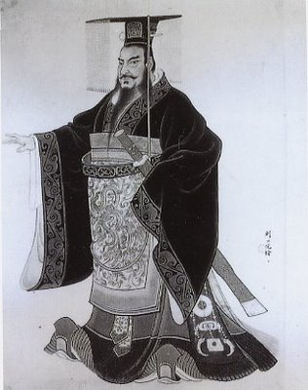
You are required to take notes on the key word sheet provided and answer the following......
Given name
Ruling name
When he was born
When and how he died
What was special about his burial place/tomb?
The positive things he did during his time as Emperor
The negative things he did during his time as Emperor
Other interesting information
(e.g. assassination attempts, obsession with living forever, family and upbringing etc)

You must also include a timeline of Shi Huangdi’s life; showing the significant events in which he was involved and the year they occurred.

ROUGH DRAFT OF TIMELINE

I______________________________________________________I

You are to present your findings on an A3 poster, which will be graded on......

Your researched information; written neatly in your own words.
A clear heading/title
Hand drawn picture of Shi Huangdi
Other relevant pictures and diagrams
Timeline of Shi Huangdi’s life
A correctly structured bibliography
Neat and thoughtfully set out presentation
Your research and note taking skills

You can use the websites provided on the Mrs Liersch’s weebly page – www.7soserli.weebly.com, or use information found in your SOSE Alive text book on pages 104 – 109.

The due date of this project is ___________________

