Murray Darling Basin Report

The Task:
Congratulations on being chosen as a Junior Murray Darling Basin Authority Ambassador. A key part of this role is to help promote the sustainability and use of the Murray Darling Basin and help educate other school age kids about this incredible resource.

Your first assignment as a MDBA Ambassador is to do some research about the Murray Darling Basin and produce a report on your findings. We have given you a list of questions for you to answer in your report.

You need to......
- Write a report that addresses Part 1 and Part 2 clearly and accurately.
- Present your findings as typed report.
- Include a bibliography with correct referencing and setting out.
- All information must be first written as notes/key words using the research scaffold.
- Write your report in your own words – don’t use words that you don’t understand.
- Include pictures, maps and drawings.
- Websites are on Mrs Liersch’s weebly page – www.7soserli.weebly.com)

PART 1
Find the answer these questions
- How long is the Murray River?
- How long is the Darling River?
- How many square kilometres does Murray Darling Basin cover?
- What is the average annual rainfall in the Murray Darling Basin?
- Who uses the water and what for?
- What kinds of crops grown using Murray Darling water?
- How much water is actually used?
- How much is lost to evaporation?
- Who controls the use of the Murray Darling Basin and its water?
- How is the Murray Darling Basin used for recreation?

PART 2
Many different problems face the River Murray. Choose 2 of the following and explain how they pose a threat to the river and what can be done to improve the situation.
- High salinity levels
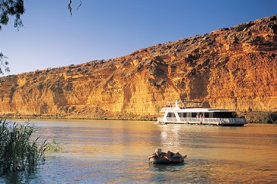
- Introduced species
- Endangered species
- River Bank Erosion
- Algal Blooms
- Acid sulphate soils
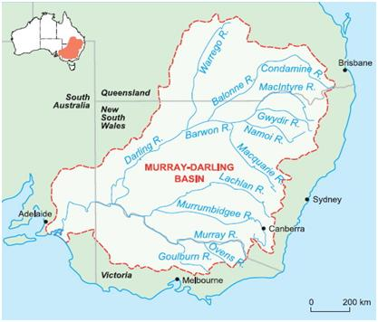
- Dredging of the Murray Mouth
- Weirs, locks and their effect on the environment

Due Date: __________________________

