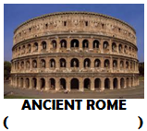

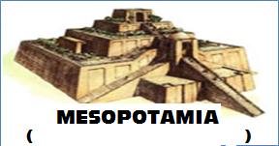
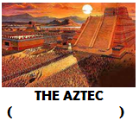
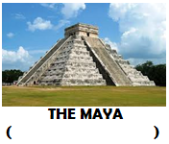
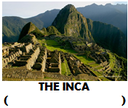

____________________________________________cut out bottom section and stick into your book____________________________________________________
Ancient Civilisations Timeline Activity
- Draw a timeline (like the one above) on a piece of A3 cardboard (make sure you space the gaps evenly).
- Label each Ancient Civilisation with the period it existed.
- Use a bracket to show the amount of time each civilisation lasted in history.
- Stick each Ancient Civilisation onto the correct part of your timeline.
- Write at least 2 interesting facts above each civilisation (websites are on Mrs Liersch’s weebly page – 7soserli.weebly.com)
- Add an appropriate title at the top of the page.
- You will be given a grade for your timeline out of 20.

