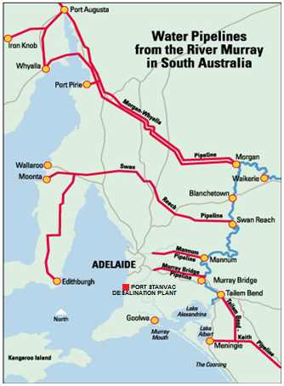
THE ADELAIDE DESALINATION PLANT
Up until recently, 60 % of Greater Adelaide’s water supply is sourced from the River Murray. Regional centers and country towns such as Port Augusta, Whyalla & Port Pirie are 100% dependent on the River Murray for water; regardless of the climate situation as there are no other alternative sources of supply for these areas.

With the Murray River under so much stress during the recent drought and the lack of any long term water security for South Australia; the state government decided to build something called a ‘desalination plant’ to sure up our water supply for the future.

The Adelaide Desalination Plant is seen by some as a vital part of South Australia’s future and an absolute necessity for our state. Others don’t agree and have been quite opposed to the idea of it being built. Your task is to research the following questions and to come to your own conclusion about the Adelaide Desalination Plant.

Research Points
- What is desalination?
- How does it work?
- Why does South Australia need a desalination plant?
- How much did the desalination plant cost to build and how much to run?
- How much water does the desalination plant produce?
- What are the positives about desalination in SA?
- What are the negatives about desalination in SA?
- Do you agree with the construction of the Adelaide Desalination Plant? Why?
(websites are on Mrs Liersch’s weebly page – www.7soserli.weebly.com)

*You are to write all information as dot points first; then convert the information into you own words in your good copy.
*Websites need to be recorded and added to your bibliography for every piece of information that you have found.
*Type up your information on the computer and present it on an A3 poster (250 words min).
* Include a Title along with relevant pictures and diagrams.
Due date – _________________________

